|  |  |
| --- | --- |
| **Name** | **ID** |
| **Mayar Ahmed Ibrahim** | **20200572** |
| **Sara Salah Mohamed** | **20200216** |

**Banknote Authentication Problem**

**Learning from Data**

**Lab Task 2**

1. **ML Structure design**

* We have 3 layers:

Layer 1: contains 4 neurons.

Layer 2: contains 4 neurons.

Layer 3: contains 1 neurons.

* The activation function for each layer :

'sigmoid' with kernel initializer 'uniform'.

* Initial set of weights:

get_weights() built-in function returns the weights of the layer as a list of Numpy arrays in a uniform random values.

1. **Experimental Design and analysis of the results**

* With running 50 epochs of training on the training set. We got accuracy=99.75308641975309

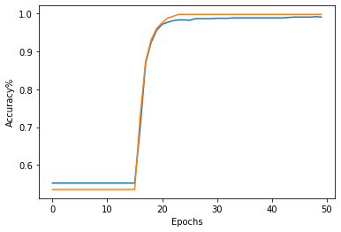

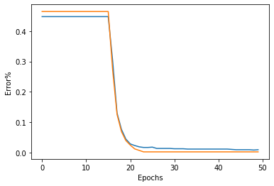

1. **ROC curve and recommended the best weight**

* **Shape, square

  Description automatically generated**The Multilayer neural network is better than Single layer neural network Because the dataset cannot be separated with a linear equation (one line) we need to spirit it with more than one line to get a good classification
* **the performance of a classification algorithm**.

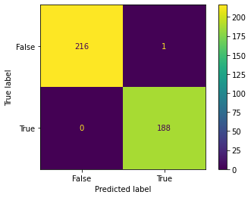

* **Recommened the best weigths**

